**Microprocessor and Computer Architecture**

**UE21CS251B**

**4th Semester, Academic Year 2022-23**

Date:

|  |  |  |
| --- | --- | --- |
| Name: Atharva Menkudle | SRN:PES2UG21CS104 | Section  B |

Week#____1_______ Program Number: ____1___

Title of the Program

**Write an ALP using ARM instruction set to check if a number stored in a register is even or odd. If even, store 00 in R0, else store FF in R0**

1. ARM Assembly Code(1)
2. Output Screen Shot (1)

The output should be verified for both even and odd numbers.

ARM Assembly Code

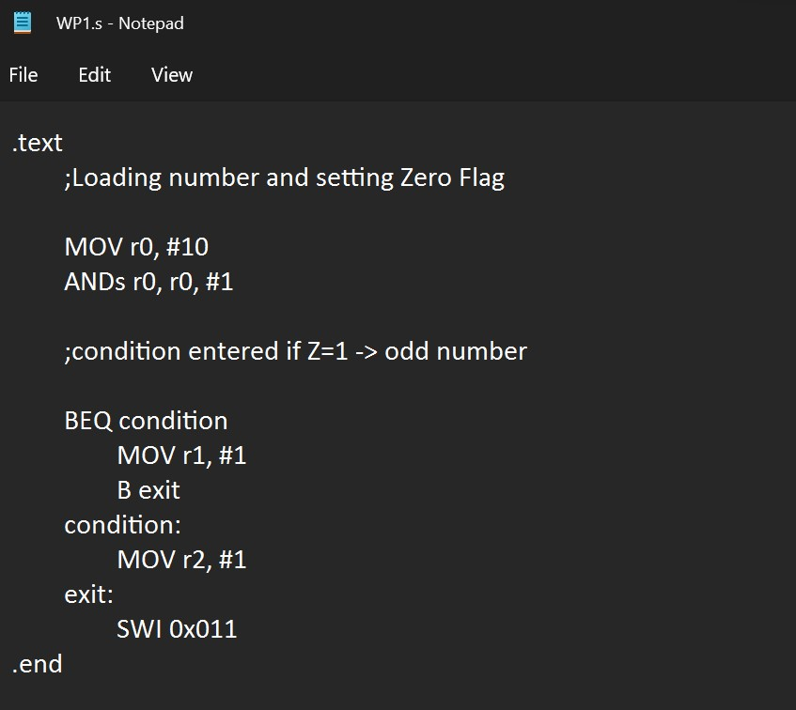

Output Screen Shot

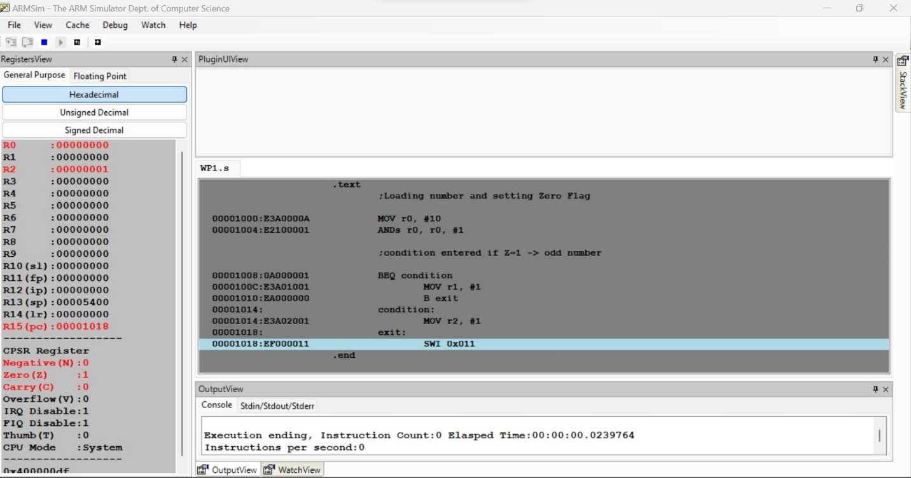

**Microprocessor and Computer Architecture**

**UE21CS251B**

**4th Semester, Academic Year 2022-23**

Date:

|  |  |  |
| --- | --- | --- |
| Name: Atharva Menkudle | SRN: PES2UG21CS104 | Section  B |

Week#____1_______ Program Number: ____2___

Title of the Program

**Write an ALP to compare the value of R0 and R1, add if R0 = R1, else subtract**

ARM Assembly Code

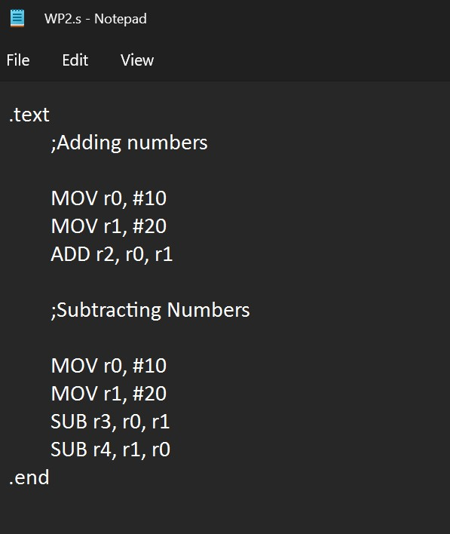

Output Screen Shot

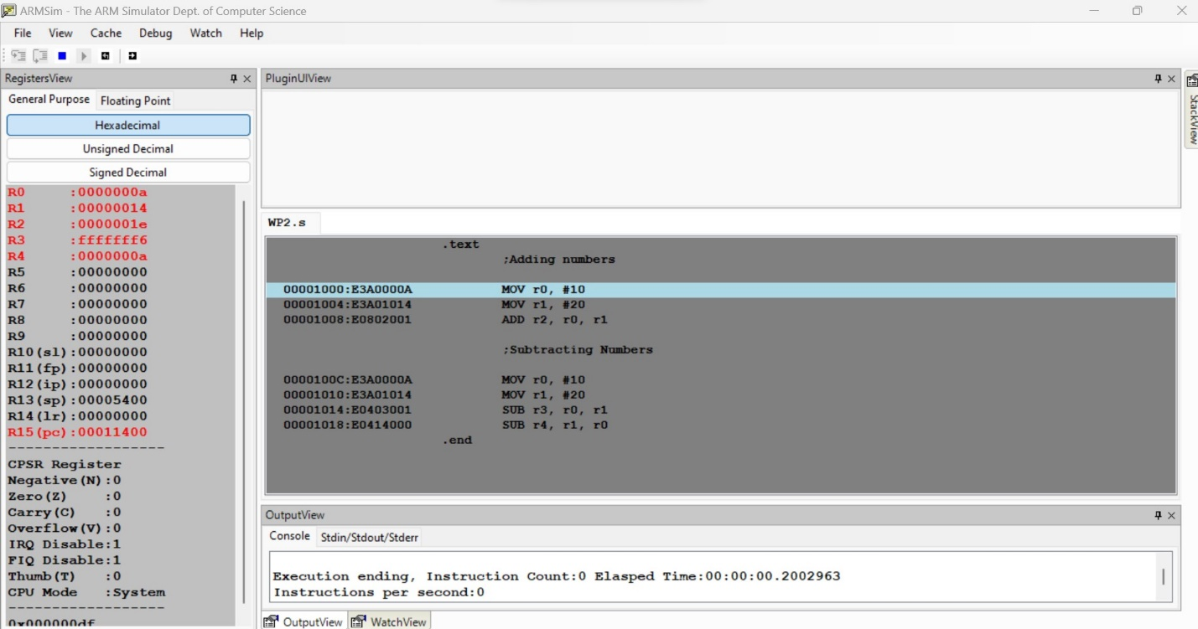

**Microprocessor and Computer Architecture**

**UE21CS251B**

**4th Semester, Academic Year 2022-23**

Date:

|  |  |  |
| --- | --- | --- |
| Name: Atharva Menkudle | SRN: PES2UG21CS104 | Section  B |

Week#____1_______ Program Number: ____3___

Title of the Program

**Based on the value of the number in R0, Write an ALP to store 1 in R1 if R0 is zero, Store 2 in R1 if R0 is positive, Store 3 in R1 if R0 is negative. (Program shown in class)**

ARM Assembly Code

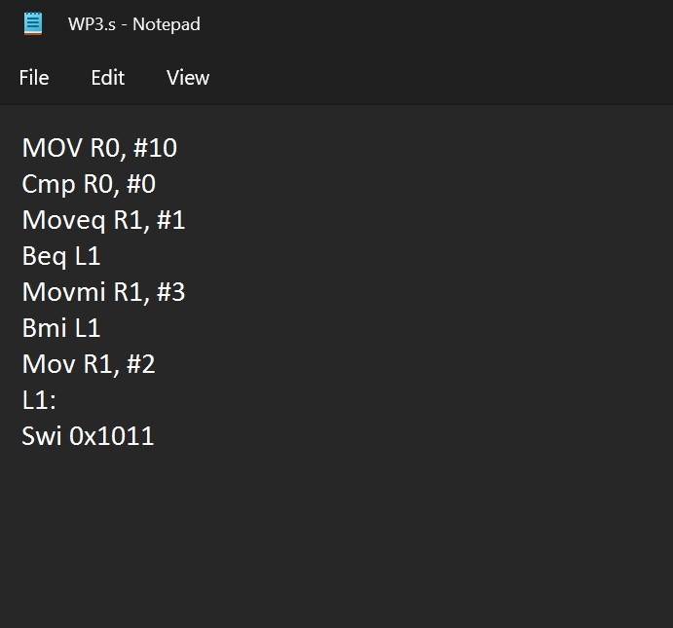

Output Screen Shot

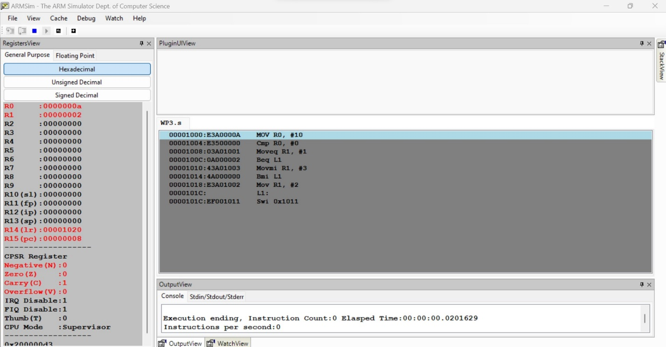

**Disclaimer:**

* The programs and output submitted is duly written, verified and executed by me.
* I have not copied from any of my peers nor from the external resource such as internet.
* If found plagiarized, I will abide with the disciplinary action of the University.

Signature: Atharva Menkudle

Name: Atharva Menkudle

SRN: PES2UG21CS104

Section: B

Date: 12/1/2023